2 – Intro to Regression and Conditional Distributions

2.1 – Conditional Distributions
As discussed in Section 0, regression in general refers to the process of estimating conditional expectations (i.e. means) and variances of a given outcome of interest. This is a bit restrictive, more generally we are interested understanding how the distribution of the response variable ($Y$) relates to or is associated with a set of variables called predictors ($X$’s). How the mean of the response and the variance of the response relates to the $X$’s is generally what we consider, but we could also consider how the median or the 75th percentile of $Y$ relates to the $X$’s as well.

For simplicity in this section we will restrict our attention to the case where we have single predictor $X$. In this case, regression involves trying to understand how the distribution of the response $Y$ varies across the subpopulations defined behind the predictor $X$. We call this the conditional distribution of Y given X.

Notation:
$Y|X$ ~ conditional distribution of $Y$ given $X$
$Y|X=x$ ~ conditional distribution of $Y$ given $X=x$, where $x$ = specific value of $X$

Note: If we write $Y|X$ it is always understood we mean $Y|X=x$, but we will be explicit when were are interested a certain subpopulation where $X=x$ specifically.

Our focus will be on mean and variance of the condition distribution of $Y|X$

Mean and Variance Functions
In regression we first need specify a functional form for the mean and variance functions that we wish use.
$E(Y|X) = E(Y|X=x)$ ~ this is the population mean of the response $Y$ for the
subpopulation where $X=x$. Other common notations for
this would be $μ_{Y|X}$ or $μ_{Y|X=x}.$

$Var(Y|X) = Var(Y|X=x)$ ~ this is the population variance of the response $Y$ for the
subpopulation where $X=x$. Other common notations
for this would be $σ_{Y|X}^{2}$ or $σ_{Y|X=x}^{2}$.

Both of these are functions of $X$ in a mathematical sense as will see in Example 2.3 (pg. 21).
Example 2.1 – Dimensions of Malignant and Benign Breast Tumor Cells
These data come from a study regarding the use of fine needle aspiration (FNA) to determine whether a breast tumor is malignant or benign. This work is the result of a collaboration at the University of Wisconsin-Madison between Prof. Olvi L. Mangasarian of the Computer Science Department and Dr. William H. Wolberg of the departments of Surgery and Human Oncology who collected and analyzed these data in several published works.
Here is link to website explaining more about this data and the FNA method (http://pages.cs.wisc.edu/~olvi/uwmp/cancer.html).
In FNA tumor cells are extracted from a breast tumor using a needle and the cells are then examined under a microscope and a digitized image of the tumor cells is taken. The cells nuclei in the image are then traced using a mouse and the computer then computes twelve size, shape, and texture readings from the traced cells. The final data consists of mean value, SE, and worst case (largest) value for each of these twelve cell characteristics from a sample of 579 tumors (212 Malignant and 357 Benign).
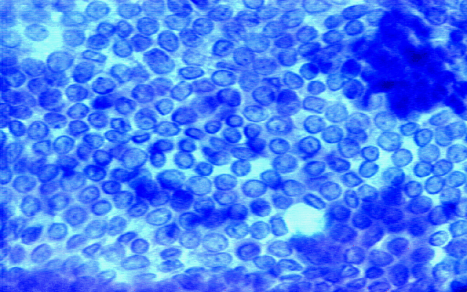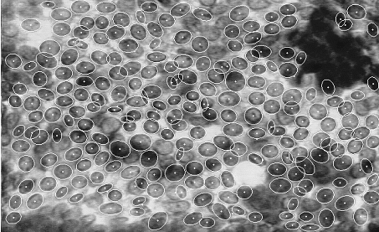
Data File: BreastDiag.JMP

Variable Descriptions:
- Id – patient ID number
- Diagnosis – M = malignant, B = benign (212 M, 357 B)
Mean of the measured cells on each of the characteristics below:
- Radius – mean of distance from center to points on the perimeter (100 μm)
- Perimeter – perimeter of cell
- Area – area of the cell
- Smoothness – local variation in radius lengths
- Compactness - $\frac{perimeter^{2}}{area}-1.0$
- Concavity – severity of concave portions of the contour
- ConcavePts – number of concave portions of the contour
- Symmetry – measure of cell symmetry
- FracDim – “coastline approximation” – 1.0
SE of the measured cells on each of the characteristics below:
- serad, seperi, searea, sesmoo, secomp, seconc, seconpts, sesym, sefd

Worst case values of the measured characteristics (mean of three largest values):
- wrad, wperi, warea, wsmoo, wcomp, wconc, wconpts, wsym, wfd
Data in JMP – BreastDiag.JMP
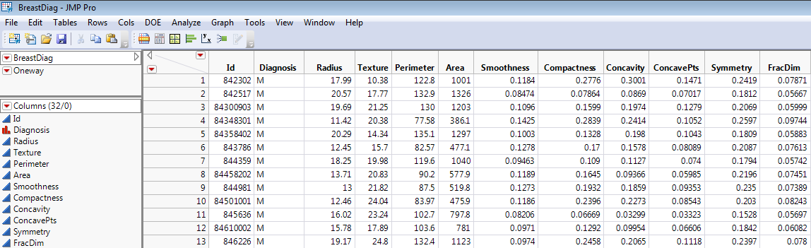

For this example we will use $Y$ = cell radius as the response and $X$ = tumor status (B or M) as the predictor. For the regression of $Y$ on $X$ were interested in understanding conditional distribution of cell radius given diagnosis of tumor cell (B or M), i.e. Y|X or Radius|Diagnosis. Select Analyze > Fit Y by X in JMP and put Radius in the $Y$, Response box and Diagnosis in the $X$, Factor box as shown below.
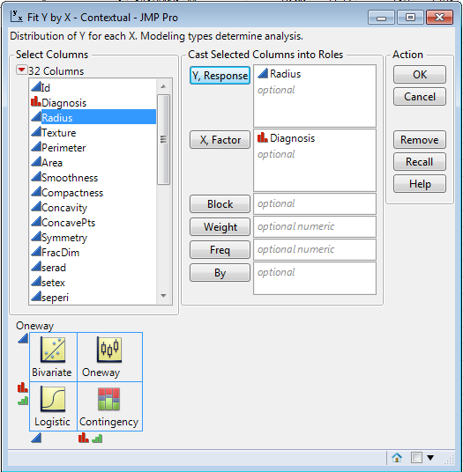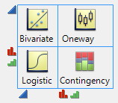
Here I have selected the following options from the Oneway Analysis pull-down menu: Means and Std Dev, Normal Quantile Plots, Densities > Compare Densities, and from the Display Options pull-out menu I have selected Histograms & Points Jittered.
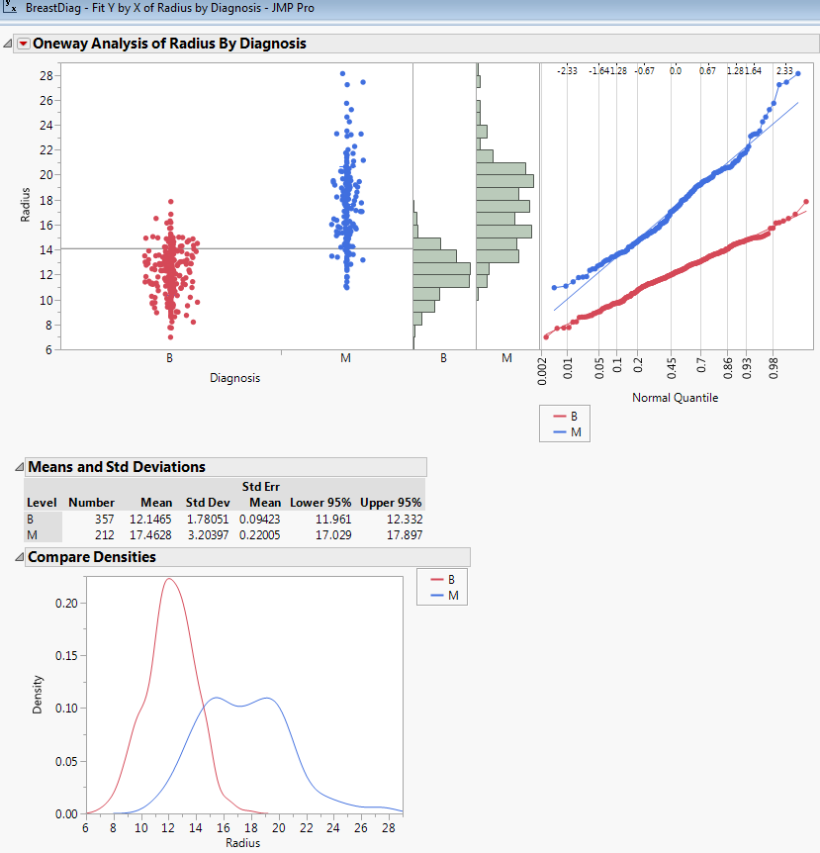
What can we say about the conditional distribution of Y|X or Radius|Diagnosis?

Estimated Conditional Mean and Variances
$$\hat{E}\left(Radius | Diagnosis=B\right)=$$

$$\hat{E}\left(Radius | Diagnosis=M\right)=$$

$\hat{Var}\left(Radius | Diagnosis=B\right)=$ $\hat{SD}(Radius|$Diagnosis=B) =

$\hat{Var}\left(Radius | Diagnosis=M\right)=$ $\hat{SD}(Radius|$Diagnosis=M) =

In your introductory statistics course what test would be used to compare the conditional expectations for these two populations? Sounds strange stated this way, but I am essentially asking what test would be used to conduct the following hypothesis test?

$NH: μ_{B}=μ_{M}$ or $NH:E\left(Radius | Diagnosis=B\right)=E(Radius|Diagnosis=M)$
$AH:μ_{B}≠μ_{M}$ or $AH:E\left(Radius | Diagnosis=B\right)≠E(Radius|Diagnosis=M)$

Notes:
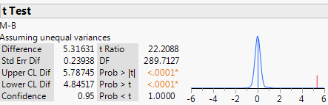

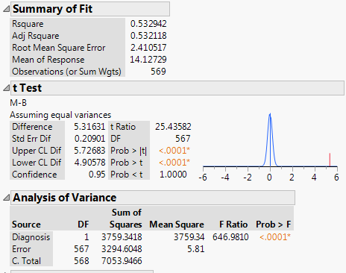
Notes:
2.2 – Coefficient of Determination (R-Square $R^{2})$

In the output from the pooled t-test above you will notice in the Summary of Fit box there is quantity labeled Rsquare = .532942 or 53.2942%. This presents the variation explained by conditioning or regressing cell radius on the diagnosis/tumor type. What do we mean by variation explained? The plots below demonstrate this important concept.

Conditional Distributions (Radius|Tumor Type)
Radius|Benign Radius|Malignant
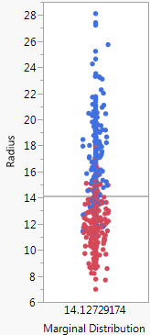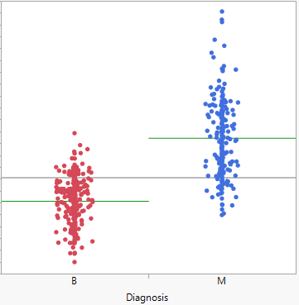

The total variation in the cell radii in this study is measured by sum of the squared deviations $(SS_{Tot})$ around the grand or overall mean of the cell radii.

$SS_{Tot}=\sum_{i=1}^{n}{{\left(y_{i}-\overline{y}\right)}^{2}=7053.95}$ This also sometimes denoted as $SYY$.

By taking diagnosis into account, i.e. regressing cell radii on diagnosis we consider the variation around the mean cell radius for each group.

For benign tumors we have: For malignant tumors we have:
$SS_{B}=\sum_{Benign Cells}{{\left(y_{i}-{\overline{y}}_{B}\right)}^{2}}$ $SS_{M}=\sum_{Malignant Cells}{{\left(y_{i}-{\overline{y}}_{M}\right)}^{2}}$
$=1128.60$ $=2166.00$

Thus variation left unaccounted for after taking tumor type into consideration is:

$SS_{Error}=1128.60+2166.00=3294.60$.
This is also denoted as $RSS$ = residual sum of squares, thus $RSS=3294.60$.

Comparing the total variation to the error variation after taking tumor type into account in the form of a ratio we have:

$$\frac{SS_{Error}}{SS_{Tot}}=\frac{RSS}{SYY}= \frac{3294.60}{7053.95}=.4671 or 46.71\%$$

This represents the percentage of the total variation in the response not explained by taking tumor type into account, i.e. not explained by the regression of cell radius (Y) on tumor type (X). Thus the percentage of total variation explained by the regression of cell radius on tumor type is given by:

$$R-Square \left(R^{2}\right)=1- .4671= .5329 or 53.29\%$$

Thus by taking tumor type into account we can explain 53.29% of the total variation in the observed cell radii in this study.

A general formula for the coefficient of determination or R-square is:

$$R^{2}=\frac{Total Unexplained Variation in Marginal-Total Unexplained Variation in Conditional}{Total Unexplained Variation in Marginal}$$

$$R^{2}=\frac{Total Variation in the Response-Variation Unexplained by the Regression}{Total Variation in the Response}$$

$$R^{2}=\frac{SS_{Tot}-SS_{Error}}{SS_{Tot}}= \frac{SYY-RSS}{SYY}$$

$$R^{2}=1-\frac{SS_{Error}}{SS_{Tot}}=1- \frac{RSS}{SYY}$$

The difference between the total variation in the response and the variation left unexplained by the regression is called the Sum of Squares for Regression ($SS_{Reg})$, i.e.

$$SS_{Reg}=SS_{Tot}-SS_{Error}=SYY-RSS$$

The $SS_{Reg}$ is the variation explained by regression model.

Wiki entry for Coefficient of Determination $(R^{2})$

http://en.wikipedia.org/wiki/Coefficient_of_determination

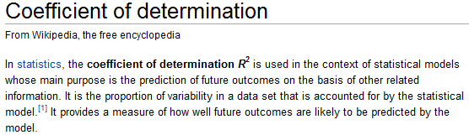

Example 2.2 – Age (yrs.) and Weight (kg) of Paddlefish
These data were collected by Ann Runstrom of the Iowa DNR/USFWS. Paddlefish were sampled from three different pools (sections) of the Mississippi River. Each fish sampled was weighed and their fork length measured. Also a determination of their age (yrs.) was made by again looking at growth rings on their scales.
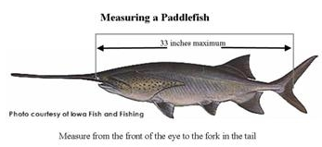

Consider the regression of $Y$ = weight (kg) on $X$ = age (yrs.), restricting our attention to paddlefish 2 – 8 years of age. (Data File: Paddlefish (2-8).JMP)

Marginal Distribution (Y) Conditional Distributions Y|X
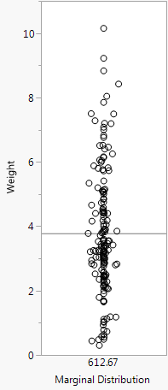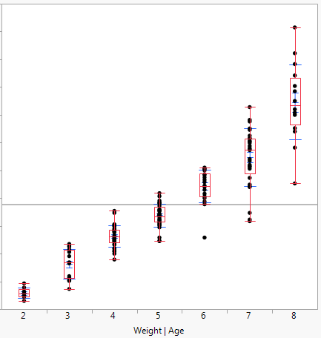

Total variation in the response (Y)
$$SS_{Tot}=SYY= \sum_{i=1}^{n}{{\left(y_{i}-\overline{y}\right)}^{2}=612.67 kg^{2}}$$

The residual variation (RSS) is found by sum the squared deviations from the subpopulation means determined by age (yrs.)

$$SS_{Error}=RSS= \sum_{k=2}^{8}{\sum_{i=1}^{n_{k}}{{\left(y_{ik}-{\overline{y}}_{k}\right)}^{2}}}=82.10 kg^{2}$$

Here,
$$y_{ik}=weight of the i^{th}fish in subpopulation sample where Age=k yrs.$$
$${\overline{y}}_{k}=sample mean weight of fish where Age=k yrs, k=2,3, …,8$$

Thus the $R^{2}$ for the regression of weight ($Y$) on age ($X$) is,

$$R^{2}=1-\frac{82.10}{612.67}=.866 or 86.6\%$$

Thus 86.6% of the variation in paddlefish weight can be explained by the regression on age.

This $RSS$ formula above is a bit clunky and probably feels like it fell out of the sky. Let’s introduce some cleaner notation for our regression of weight on age.

The mean function for our regression model is:

$E\left(Weight | Age=k\right)=μ_{k}$ for $k=2,3,…, 8$

The model for a random sample of paddlefish between 2 and 8 yrs. of age is

$y_{ik}=μ_{k}+e_{ik}$ $i=1, …,n_{k}$ and $k=2, 3, …, 8$

Intuitively the estimated mean function is given by

$$\hat{E}\left(Weight | Age=k\right)= {\hat{μ}}_{k}={\overline{y}}_{k} \sim sample mean of all k yr. old fish in sample$$

In general, the estimated mean of the response (Y) given the predictors (X) is called the fitted value ($\hat{y})$ and the difference between the observed response value and the fitted value is called the residual ($\hat{e}=y-\hat{y}$).

With the understanding that for this example the fitted values are the sample means for the given ages (yrs.) we can express the RSS as

$$RSS= \sum_{i=1}^{n}{{\left(y_{i}-{\hat{y}}_{i}\right)}^{2}}=\sum_{i=1}^{n}{{\hat{e}}_{i}^{2}}=sum of the squared residuals=82.10$$

$$SYY= \sum_{i=1}^{n}{{\left(y_{i}-\overline{y}\right)}^{2}=612.67}$$

Marginal Distribution (Y) Conditional Distributions Y|X
$${The R}^{2}Again$$

$$R^{2}=1-\frac{RSS}{SYY}=1-\frac{82.10}{612.67}=1-.134= .866 or 86.6\%$$

Notes:

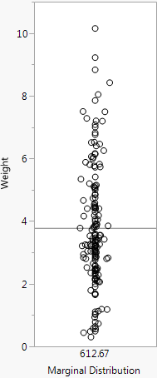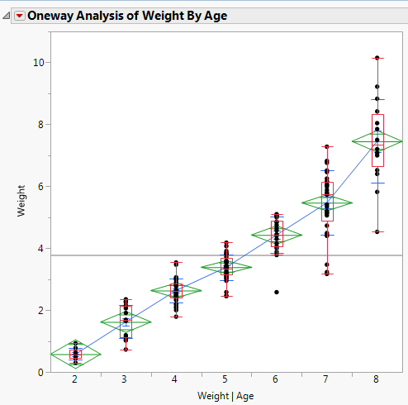
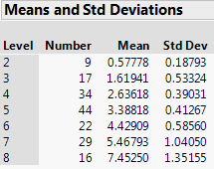

Age (X) | Sample Size  $$(n_{k})$$ | $$\hat{E}\left(Weight | Age\right)$$  $$\hat{y}$$ | $$\hat{Var}(Weight|Age)$$ | RSS Contribution  $$=\left(n_{k}-1\right)*Var(Weight|Age)$$
2 yrs. | 9 | 0.578 kg | .0353 $kg^{2}$ | .2826
3 yrs. | 17 | 1.619 kg | .2843$kg^{2}$ | 4.549
4 yrs. | 34 | 2.636 kg | .1523$kg^{2}$ | 5.027
5 yrs. | 44 | 3.388 kg | .1703$kg^{2}$ | 7.323
6 yrs. | 22 | 4.429 kg | .3429$kg^{2}$ | 7.202
7 yrs. | 29 | 5.468 kg | 1.0826$kg^{2}$ | 30.314
8 yrs. | 16 | 7.453 kg | 1.8267$kg^{2}$ | 27.401
 |  |  |  | RSS = 82.10

$${The R}^{2}Again$$

$$R^{2}=1-\frac{RSS}{SYY}=1-\frac{82.10}{612.67}=1-.134= .866 or 86.6\%$$
Additional Questions:

Does weight increase linearly with age, i.e. is the average weight gain per year constant?

Is the variation constant, i.e. $is Var\left(Weight | Age\right)=constant?$

2.3 – More on the Mean and Variation Functions: $E\left(Y | X\right) \& Var(Y|X)$
One can show that the following relationships between the mean and variance of the response and the conditional distribution of Y|X hold:
$E\left(Y\right)=E_{X}\left(E\left(Y | X\right)\right) or E(E(Y$|X))
and for the variance of the response we have
$$Var\left(Y\right)=E_{X}\left(Var\left(Y | X\right)\right)+Var\left(E\left(Y | X\right)\right).$$
We can demonstrate these relationships using summary statistics and estimates of these quantities from the example above.
From the example above we have
Age (X) | Sample Size  $$(n_{k})$$ | $$\hat{E}\left(Weight | Age\right)$$  $$\hat{y}$$ | $$\hat{Var}(Weight|Age)$$ | RSS Contribution  $$=\left(n_{k}-1\right)*Var(Weight|Age)$$
2 yrs. | 9 | 0.578 kg | .0353 $kg^{2}$ | .2826
3 yrs. | 17 | 1.619 kg | .2843$kg^{2}$ | 4.549
4 yrs. | 34 | 2.636 kg | .1523$kg^{2}$ | 5.027
5 yrs. | 44 | 3.388 kg | .1703$kg^{2}$ | 7.323
6 yrs. | 22 | 4.429 kg | .3429$kg^{2}$ | 7.202
7 yrs. | 29 | 5.468 kg | 1.0826$kg^{2}$ | 30.314
8 yrs. | 16 | 7.453 kg | 1.8267$kg^{2}$ | 27.401
 |  |  |  | RSS = 82.10
and the estimated distribution of $X$ = Age (yrs.) is given by:
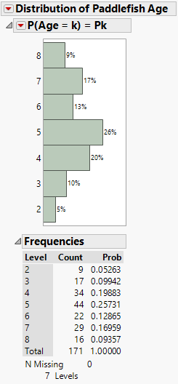
The sample-based version of the expectation relationship is given by:
$$\hat{E}\left(Y\right)={\hat{E}}_{X}\left(\hat{E}\left(Y | X\right)\right)$$

Here we have,
$$\hat{E}\left(Y\right)=\overline{y}=3.782 kg$$
and
$${\hat{E}}_{X}\left(\hat{E}\left(Y | X\right)\right)=weighted average of the \hat{E}\left(Weight | Age=k\right)$$
$$=\sum_{k=2}^{8}{{\hat{P}}_{k}\hat{E}(Weight|Age=k)}$$
$$= {\hat{P}}_{2}\hat{E}\left(Weight | Age=2\right)+{\hat{P}}_{3}\hat{E}\left(Weight | Age=3\right)+…+{\hat{P}}_{8}\hat{E}(Weight|Age=8)$$
$$=.0526∙.5778+ .09942∙1.6194+…+.09357∙7.4525$$
$= 3.782 kg$.

For the variance we have,
$$\hat{Var}\left(Y\right)=s^{2}=3.604 kg^{2}$$
and
$$\hat{Var}\left(Y\right)=\hat{E}\left(\hat{Var}\left(Y | X\right)\right)+\hat{Var}(\hat{E}\left(Y | X\right))$$
$$=weighted average of the conditional variances+variance of the conditional expectations$$

We will handle the two terms on the right-hand side separately.

First term
$$\hat{E}\left(\hat{Var}\left(Y | X\right)\right)=weighted average of the conditional variances$$
$$=\sum_{k=2}^{8}{{\hat{P}}_{k}\hat{Var}(Weight|Age=k)}$$
$$= .0526∙{\left(.1879\right)}^{2}+.09942∙{\left(.5332\right)}^{2}+…+.09357∙{\left(1.3516\right)}^{2}$$
$$= .5029 kg^{2}$$

Second Term
$$\hat{Var}\left(\hat{E}\left(Y | X\right)\right)=\hat{E}[{\left(\hat{E}\left(Y | X\right)-\hat{E}\left(Y\right)\right)}^{2}]$$
$$=\sum_{k=2}^{8}{{\hat{P}}_{k}}{\left(\hat{E}\left(Weight | Age=k\right)-\hat{E}\left(Weight\right)\right)}^{2}$$
$$=.0526{\left(.5778-3.782\right)}^{2}+.09942{\left(1.6194-3.782\right)}^{2}+…+.09357{\left(7.4525-3.782\right)}^{2}$$
$$=3.1028 kg^{2}$$

Combining the terms on the right-hand side we have,
$$\hat{Var}\left(Y\right)=\hat{E}\left(\hat{Var}\left(Y | X\right)\right)+\hat{Var}\left(\hat{E}\left(Y | X\right)\right)=.5029+3.1028=3.604 kg^{2}$$

The variance result, though more theoretically difficult, is more important. The consequence of this result is the following:
$$Var\left(Y\right)≥Var(E\left(Y | X\right))$$
Why?

This says by conditioning on $X$ we reduce the variation in the response, i.e. by conditioning on $X$ we can explain some of the variation in the response $Y$. Equality will only hold when $Y$ is completely independent of $X$, i.e. conditional distribution of $Y$ given $X$ is the same as the marginal distribution of $Y$.

Example 2.3 – Length and Weight of Paddlefish
These data were collected by Ann Runstrom of the Iowa DNR/USFWS. Paddlefish were sampled from three different pools (sections) of the Mississippi River. Each fish sampled was weighed and their fork length measured.

Suppose we interested in the regression of weight in kg (Y) on the fork length in cm (X) of paddlefish in these sections of the Mississippi River, i.e. what can we say about the conditional distribution of Y|X or Weight|Length. Fork length (cm) is a continuous variable in contrast to age (yrs.) which was discrete. Thus we cannot simply estimate $E(Weight|Length=x)$ and $Var(Weight|Length=x)$ by simply finding the mean and variance of the weights for all sampled fish with $Length=x$ as there may only one fish in our sample with that length.

When we have a single continuous predictor $X$ a simple scatterplot of $Y$ vs. $X$ will give us a nice visualization of the conditional distribution of $Y|X$ and properties of this distribution such as $E(Y|X)$ and $Var(Y|X)$.
Data in JMP – Paddlefish (clean).JMP
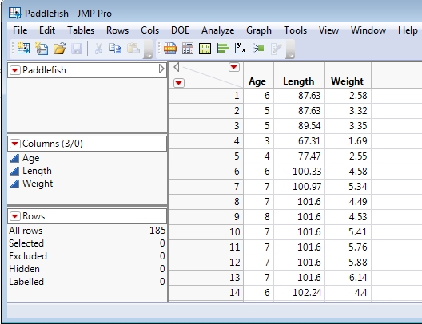

One potential work around would be to condition on ranges of similar lengths and consider the mean and variance of the weights of fish within these length ranges. This can be done easily in JMP using Cols > Utilities > Make Binning Formula option after first highlighting the column for the fork lengths of the paddlefish (see below).
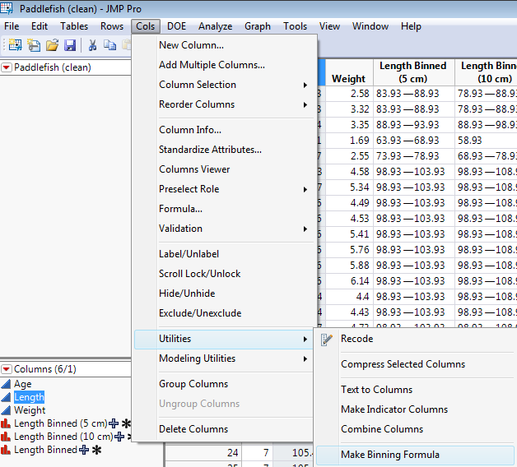

The below is the graphic that appears showing how the ranges of similar lengths will be formed. The width of the bins is set to 20 cm for these data, but it can be changed.
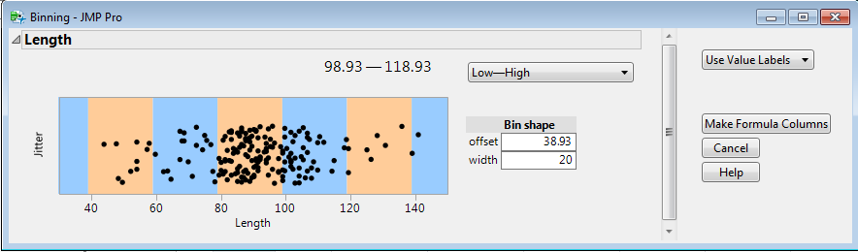

Change the field that says “Use Value Labels” to “Use Range Values” and then click Make Formula Columns. Using a bin width = 10 cm and using Fit Y by X to display the results we obtain the following.

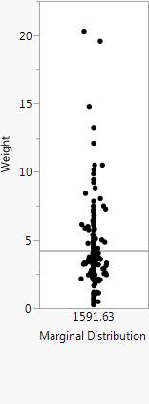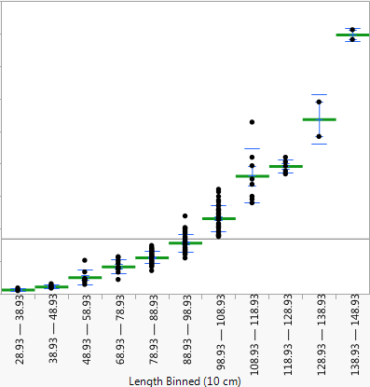

We clearly see that by conditioning on fork length we have a sizeable reduction in the residual variation in the response. The $R^{2}=.93 or 93\%$ by conditioning on 10 cm wide bins of the fork length. The table below gives the estimated mean and variance functions.
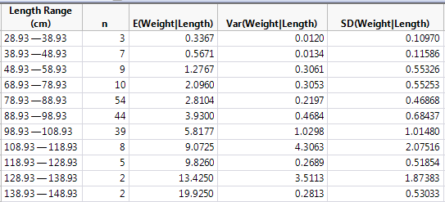
1) Does the mean weight seem to increase linearly with fork length?

2) Is the variation in weight (kg) similar across the length ranges, i.e. is
$Var\left(Weight | Length Range\right)=constant$?
In the next section we will use the idea of “binning” to form nonparametric estimates of the mean and variance functions.

In general, we don’t discretize or use binning when working with predictors that are continuous like fork length in the paddlefish study.

To obtain a scatterplot in JMP select Analyze > Fit Y by X and place the response variable in the Y, Response box and the predictor variable in the X, Factor box.
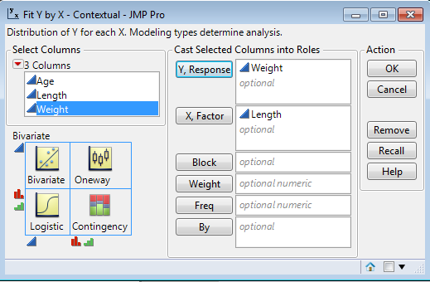 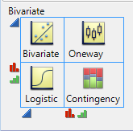

Below is a scatterplot of the Weight ($Y$) vs. Fork Length ($X$) for these data with marginal distributions of both $Y$ and $X$ added.
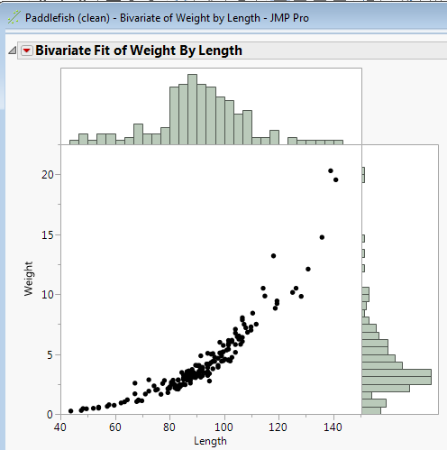

What can we say about the marginal distribution of the response?

What can we say about the conditional distribution Y|X or Weight|Length?

If we focus on the mean and variance functions, what can we say?

$$E\left(Y | X\right)= E\left(Weight | Length\right)$$

$$Var\left(Y | X\right)=Var(Weight|Length)$$

Now focusing on the mean function $E(Weight|Length) = E(Y|X)$ and realizing that this is a function $X$; what function of $X$ might we use for the mean function, $f\left(X\right)=???$

Y = Weight (kg)
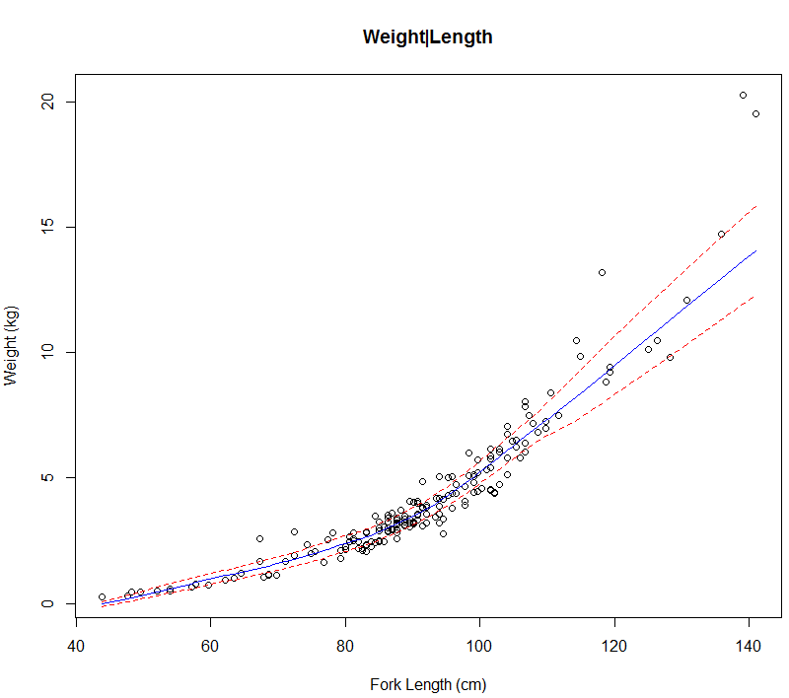
X = Fork Length (cm)

Model 1
E(Y|X) =

Model 2
E(Y|X) =

Model 3
E(Y|X) =

As we will see later, we in linear regression or ordinary least squares (OLS) regression we assume the variance function is constant, i.e. Var(Y|X) = constant.
Here we have visual evidence that this is not the case.

Conclusion:
When developing a parametric regression model we first need to specify the mean and variance functions we wish to use. This is a VERY involved process and the definitely the focus of this course. It also is an iterative process! We usually try several models and choose the “best” model amongst those considered. An important famous quote from George E. P. Box (1987):
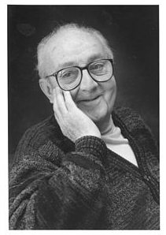
George E.P. Box
“Essentially, all models are wrong, but some are useful.”

